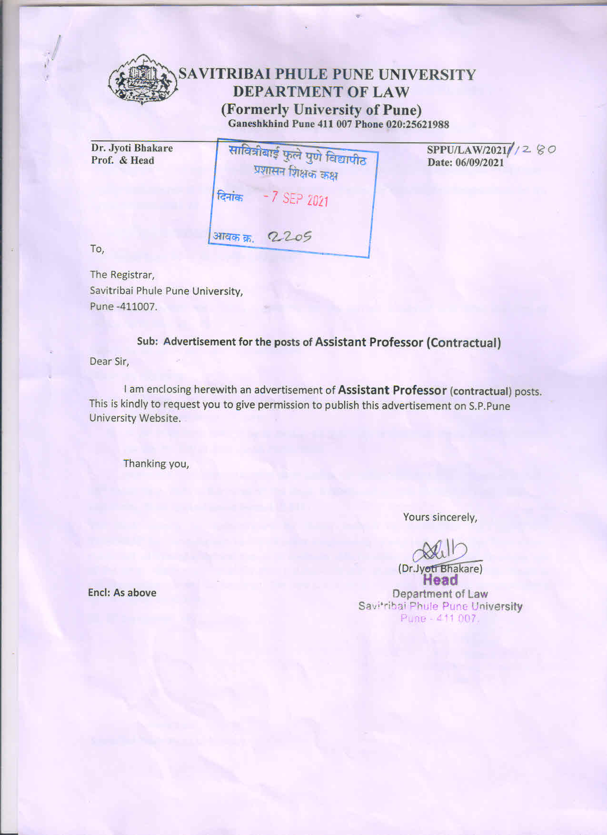

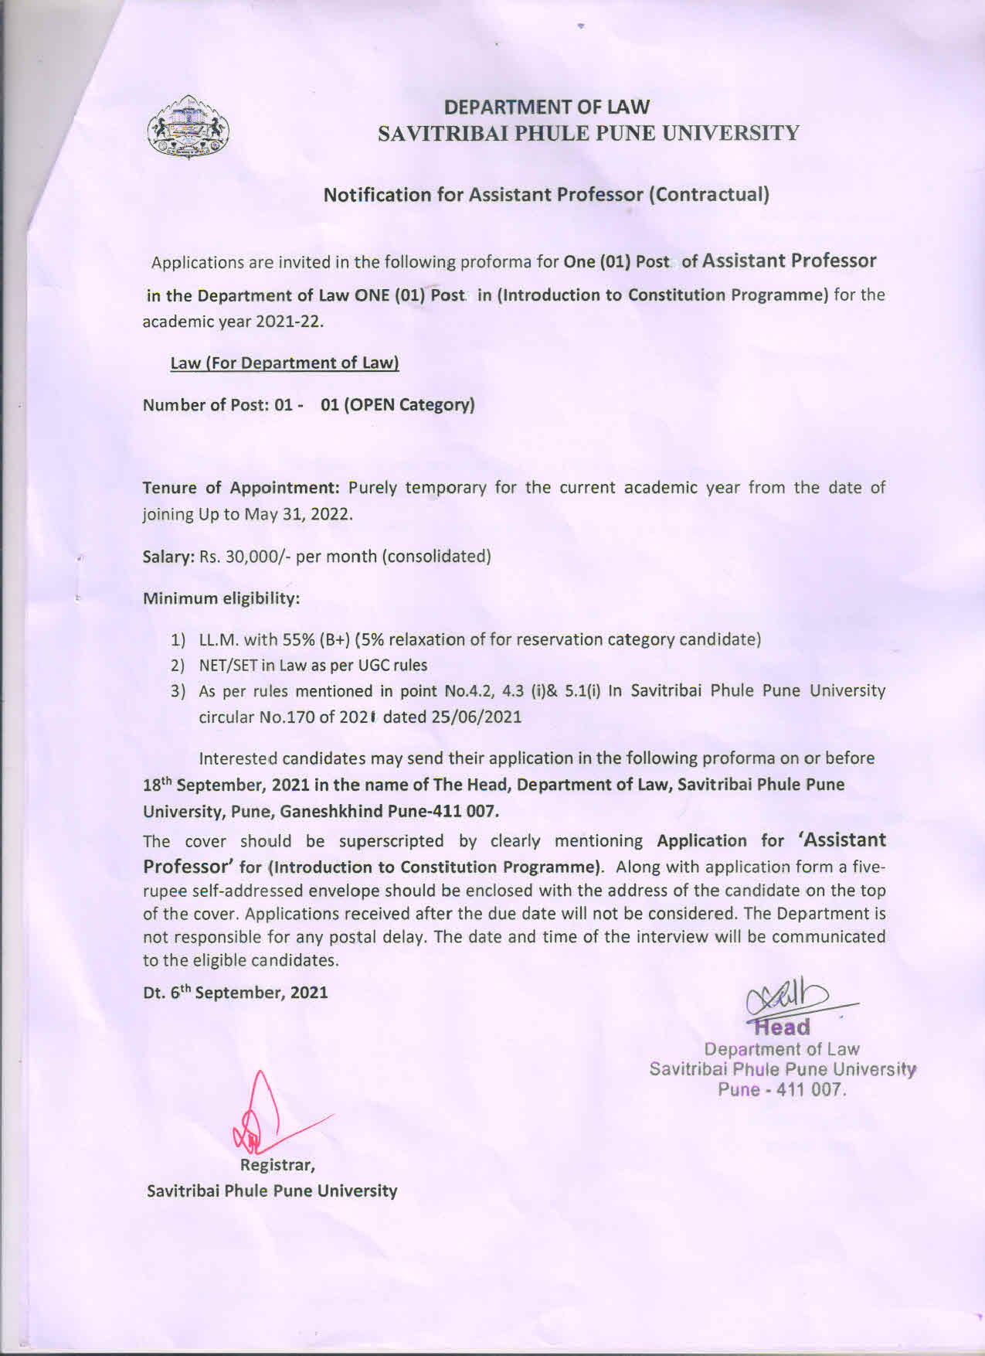

DEPARTMENT OF LAW
SAVITRIBAI PHULE PUNE UNIVERSITY
(Formerly University of Pune)
Affix latest Passport size color photograph with the signature of the candidate

Application for the post of ASSISTANT PROFESSOR (2021-22)
(Contractual)
Assistant Professor for : -----------------------------------------------------

1 | Name of the Candidate  (In Block Letter
2 | Date of Birth
3 | Educational Qualification
4 | Percentage obtained in LL.M.  Year of passing
5 | Year of passing SET/NET
6 | Category
7 | Experience if any
8 | Awards/Prizes received
9 | Address for correspondence  (E-mail &Phone numbers etc.)
10 | Research Publications
11 | Subject Specialization
12 | Any other Information

Signature of the Candidate

Declaration

I hereby declare that the information given in the application as it relates to me is true and correct. If found incorrect I will be liable for any action by the University..

Place :
Date : / /2021 Signature of the Candidate

The following documents need to be attached with attestation of the Head/Principal of the last institution or by gazetted officer.
1) Certificate of SSC.
2) Marks Statements of LL.M.,NET/SET Certificate
3) SC/ST candidates should submit validity/Caste Certificate issued by the respective designated authorities as per the regulations of the Govt. of Maharashtra.
4) Applications without sufficient information and necessary enclosures will be
rejected summarily.
- Self-addressed envelope with five rupees stamp.
6) Experience Certificate if any.

===================

